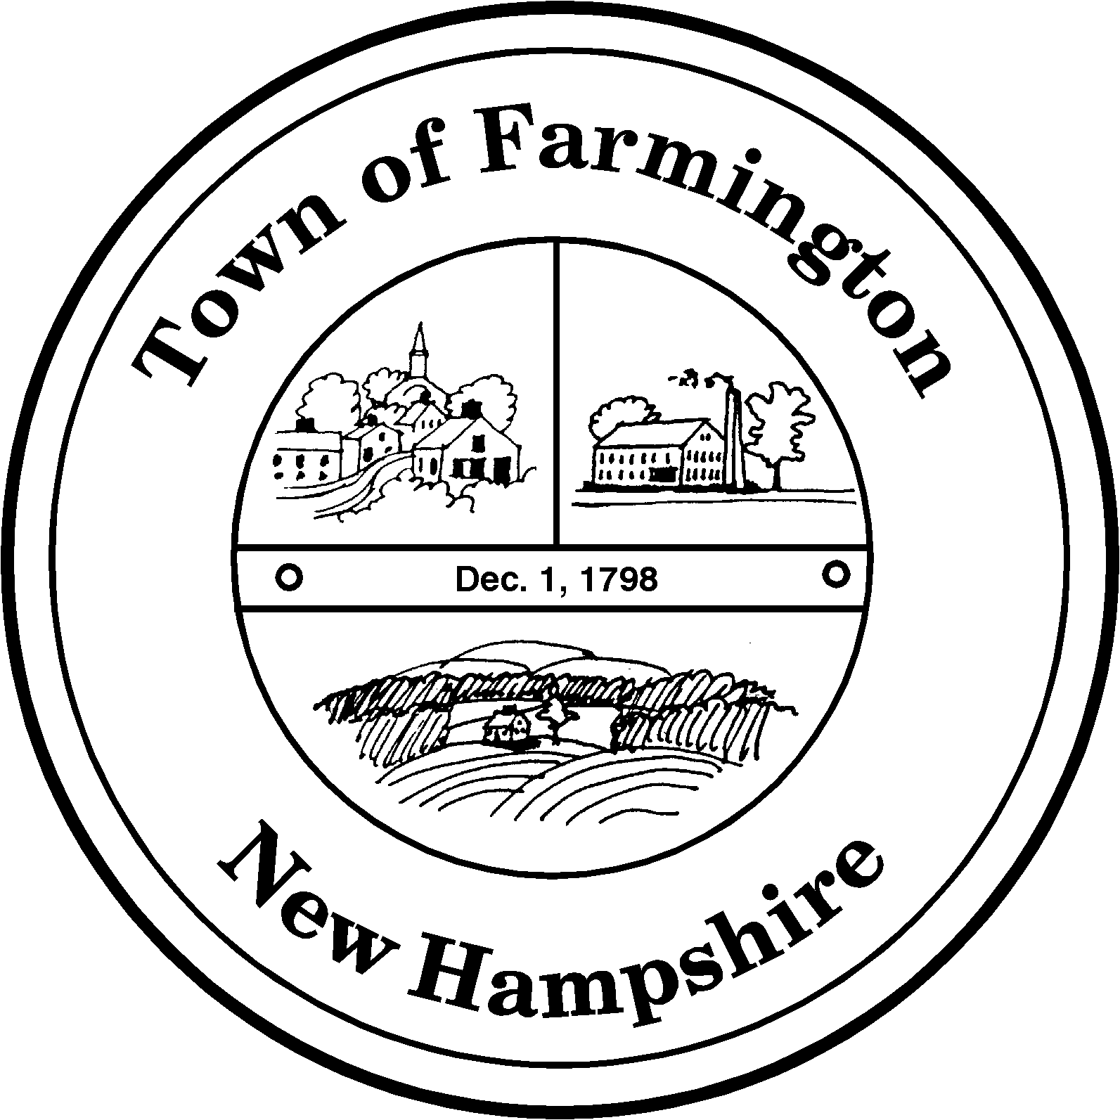
Town of Farmington
Planning and Community Development
356 Main Street
Farmington, NH 03835
Phone: (603) 755-2774
A Bicentennial Community
1798 - 1998

PLANNING BOARD MEETING

Tuesday – May 3, 2016

356 Main Street - Farmington, NH

AGENDA - 6:00 pm

BUSINESS BEFORE THE BOARD:

- Pledge of Allegiance
- Review and approve Meeting Minutes of April 5, 2016 and April 19, 2016
- Review of Groundwater Protection Overlay District and FAQs
- Review of TIF and 79-e factsheets
- Discussion of Master Plan review and update process
- Any other business to come before the Board

NEW CASES:

Application for Voluntary Lot Merger of Map R-4 Lot 1 and Map R-4 Lot 2 located at 135 Ten Rod Road by Charles and Kathleen King. The new lot will be R-4 Lot 1.

Charles Doke, Chairman

Farmington Planning Board

